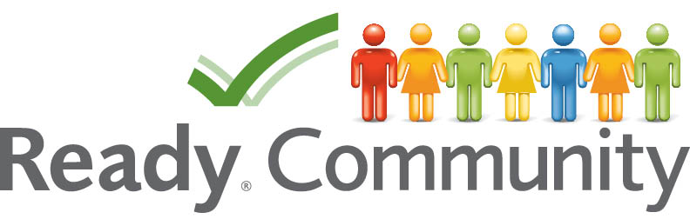
Designing a Win-Win Invitation
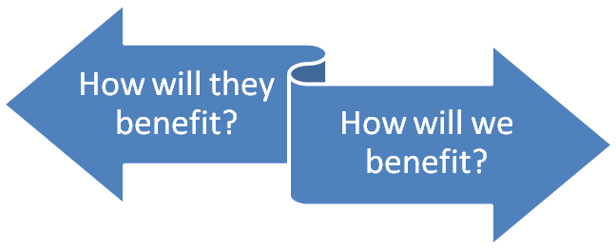

Potential Partner
Planning Team

Potential Partner | Their Benefit | Our Benefit | Who Will Contact Them

