

STEP TWO
Understanding the Situation
Vulnerability and Assessment

By Deborah Tootle
Iowa State University
University of Wisconsin
and
Don E. Albrecht
Western Rural Development Center
Utah State University

This facilitator’s guide outlines the content, activities, and handouts that should be used to teach this section. Refer to this document for detailed guidance on how to deliver ReadyCommunity Step Two.
STEP Two
Understanding the Situation

Before Starting Step Two…
Prior to moving on to Step Two, the core and planning teams should complete these activities from Step One:
- Contact the identified potential partners and invite them to Step Two meeting
- If applicable, complete the readiness activities. (Handout –“Are We Ready?” from Step One)
- Complete to-do items that were discussed and assigned during Step One’s “Questions & Discussion” at the close of Step One.

Step Two Overview
Studies have shown that resilient communities are those that can prepare for, respond to, and rebound quickly from disasters. These abilities do not happen by luck. In this step, participants learn how planning and reducing vulnerabilities contribute to resilience. They develop a better understanding of what makes residents, neighborhoods, and communities more or less vulnerable to extreme events. They learn how to identify and map the most vulnerable populations and locations in their communities.

Objectives
Participants will learn:
- Steps in disaster management
- What resilient communities look like
- How to assess vulnerability in their communities

Estimated Time to Complete Step Two Activities
Three hours plus additional time to complete the worksheets, and prepare for and host the Open House

References to CPG 101
Pages 4-7 – 4-10

Understanding the Situation
In Step Two – Understanding the Situation, Part I will be devoted to overview and discussion of disaster management, community vulnerability, and resiliency. During this period, participants will also create a disaster event time line. Part II will be hands-on, as the group learns how to conduct community vulnerability assessments. The vulnerability assessment consists of nine tasks and includes small group activities guided by worksheets. Some homework will be necessary in order for the group to complete worksheets. Worksheets are designed to provide background information to be used in the community planning processes in Steps Four, Five and Six. Finally, in Part III, participants will learn how to conduct an Open House to gather public input to ground-truth the information gathered in this section. They will also learn more about sources of information on vulnerable populations in their communities.

Advance Preparation

One Week Prior
- Follow up with local point person
  - Confirm final count
  - Discuss any questions/concerns that may have surfaced
  - Discuss any homework assignments
- Send a reminder to participants
  - Confirm date, time, location
  - Go over what they should expect, their responsibilities, homework (if any)
- Confirm food and beverages, if being provided, with local point person
- Double check logistical arrangements
- Print handouts (See “Supplies Needed” below)
- Add your contact information to the final slide in PowerPoint “ReadyCommunity – Step Two”

Day of event
- Arrange room so that participants from each county (or community) will be able to work together. A table for each group usually works well.
- Set up PowerPoint equipment with screen at front of room and tables on either side of projection equipment
- Load presentations on computer prior to session
- Place about 15 feet of heavy-duty brown paper on wall with blue painters tape
- Distribute handouts [PowerPoint presentation, Community Based Vulnerability Assessment Guidebook, extra worksheets (Worksheets 1-11 in Guidebook)]
- Place “super“ balls on tables

Supplies Needed
Handout 1 – Disaster Ranking Worksheet
Handout 2 – Data Sources, Using Census.gov
Handout 3 – Open House Fact Sheet, Ground-Truthing Open House Guide, Sample Open House Flyer
PowerPoint Presentation (optional)
Community Based Vulnerability Assessment (CBVA) Guidebook
Community Based Vulnerability Assessment Worksheets 1-11 (these are also included in the CBVA Guidebook but committee members will appreciate a second set)
* County QuickFacts (or other similar county level data summary)
Computer
Projector
Extension cord
Screen or blank wall
Sign in sheet
Flip chart, easel, and markers
Stickers (colored circles for marking the map)
Brown paper or newsprint roll
Blue painters tape
County/local maps (can be locally available street maps, county road maps, Google maps) for each county/community group
Nametags and/or tents

*Note to facilitator: County QuickFacts - You will need to locate this information for your county following the directions on Handout 2 “Using Census.gov”. Feel free to draw from other data sources if you choose as long as basic demographic and socio-economic information is included.

Resources
Developing and Maintaining Emergency Operations Plans: Comprehensive Preparedness Guide 101. FEMA.

Community Based Vulnerability Assessment: A Guide to Engaging Communities in Understanding Social and Physical Vulnerability to Disasters. Emergency Preparedness Demonstration Project. MDC, Inc. 2009.

STEP TWO Detailed Instruction
Slide 1  ReadyCommunity  Display the Welcome Slide so participants see it when they enter the room.  Welcome participants and allow time for introductions if participants are not already acquainted.  Warm up:  Ask each person to share the following information:  - Name (If they are not already acquainted)  - The first thing that comes to mind when you hear the word resilient (tell them to name something in one or two words – fast)  - (Alternate opener – Name one thing that bounces.)  Introduce today’s session. | 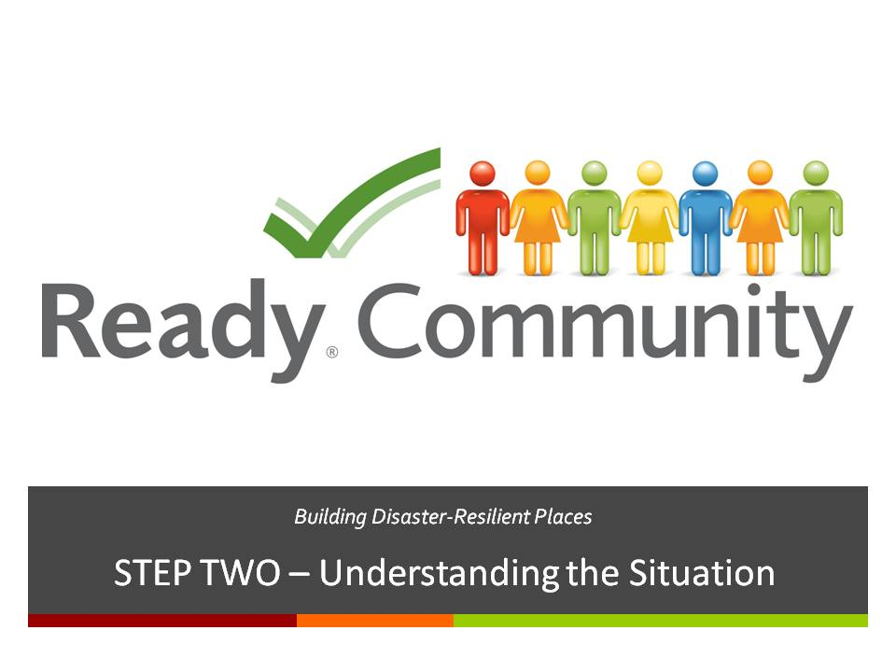  Supplies/Materials  Handout 1 – PowerPoint Presentation (optional)  Flip Chart  Easel  Markers  Brown paper on walls  Estimated Time  5-10 min. (depending on size of the group)

STEP TWO Detailed Instruction

Slide 2  A Review of What is Involved  As discussed in Step One, the ReadyCommunity process follows six basic steps as outlined in CPG 101 and shown here.  Today we are beginning our work on Step Two: Understanding the Situation. | 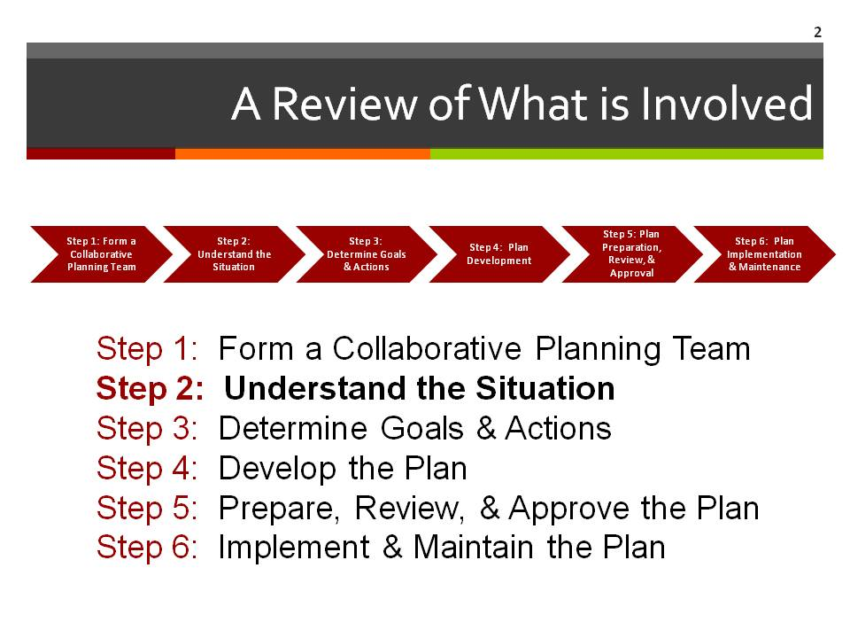  Supplies/Materials  Estimated Time  1 min.

Slide 3  Key Words Defined  According to FEMA:  Vulnerability refers to people living in the way of something that poses a hazard (a flood plain). So, for example, a person is vulnerable to flooding if they live in a low lying area in a flood zone.  Disadvantaged is the term used to describe someone that does not have the resources to respond to a hazard or disaster. For example, someone might live on the coast and need to evacuate because of a hurricane, but does not have transportation.  A person can be both vulnerable to disasters AND disadvantaged. | 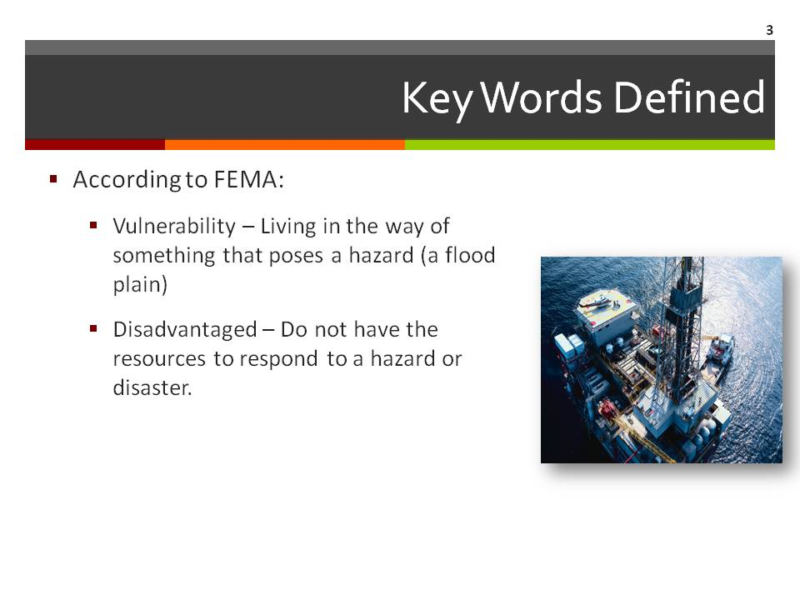  Supplies/Materials  Estimated Time  5 min.

STEP TWO Detailed Instruction

Slide 4  Hazards in Your Community  Activity  This activity requires participants to create a disaster timeline.  - Groups are to use the brown paper on the wall to develop a timeline of disasters experienced in their community.  - Participants will have 10 – 15 minutes to develop a disaster timeline going back as far as they can remember.  Have the group identify the elements listed on the slide:  - What hazards are you likely to encounter in your community? List these hazards.  - Are these hazards related to the natural environment or the built environment (man-made)?  - How would you rank these hazards according to frequency and severity of risk?  Note to facilitator: As the group explains their disaster history, list each disaster on the flip chart.  Keep the timeline up on the wall. Participants will use this information later in the vulnerability assessment.  Handout 1 – After doing the activity, have participants write the disasters on the handout and rank each event. This will help them to see what events are most likely and most catastrophic so they can plan accordingly. | 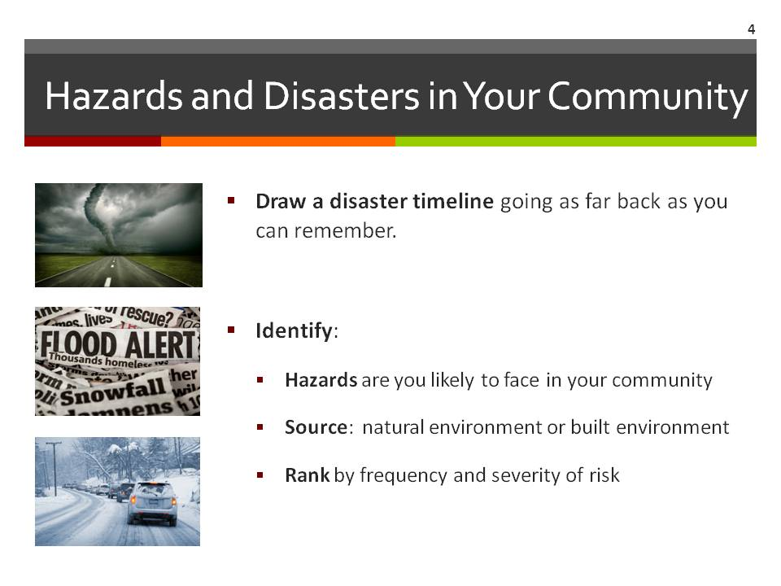  Supplies/Materials  Flip Chart  Markers  Brown paper on walls  Handout 1 – Disaster Ranking Handout  Estimated Time  20-25 min.
STEP TWO Detailed Instruction

Slide 5  Vulnerability and Resilience  Not everyone in a community is affected equally by disasters. Pre-existing structures and conditions, including social structures and conditions, are often responsible for responses and impacts to disaster. Attention to vulnerability can reduce the impacts of disasters.  The impacts of hazards will vary according to how vulnerable communities are. For example, a community where there are a large number of poor residents who don’t have the means to evacuate as floodwaters rise, will be hit much harder than a community in which most of the residents can protect their property with sandbags and evacuate. | 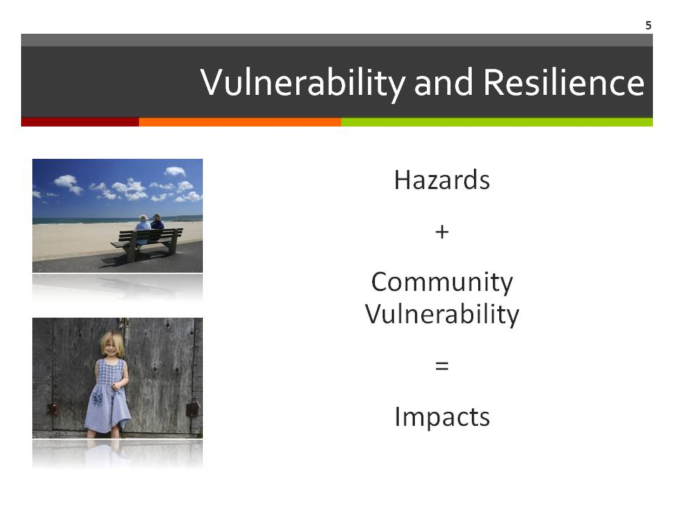  Supplies/Materials  Estimated Time  1 min.

Slide 6  Vulnerability in Your Community  It is important to consider all members of the community, and to do that, we must consider the socially vulnerable.  Ask participants to review the list of Vulnerable Populations that they generated in Step One.  And then ask participants:  - Who else may be vulnerable in the community?  - Why are these groups of people vulnerable? (Some possible answers listed below.)  - Economic conditions?  - Social conditions?  - Physical disabilities?  - Special needs?  Add responses to the flip chart. | 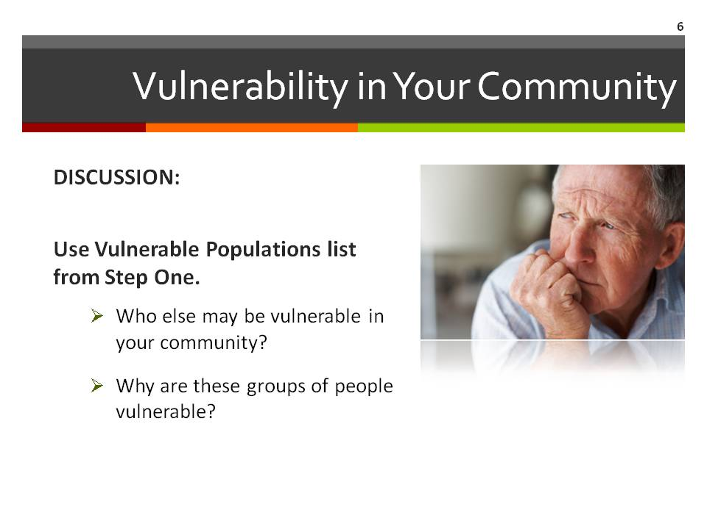  Supplies/Materials  Flip Chart  Markers  Estimated Time  10 min.
STEP TWO Detailed Instruction

Slide 7  How Well Do You Know Your Community?  Inform the group that we are going to talk about community demographics.  Demographics help:  Note to coach: You will need to locate information for your community/ county following the directions on Handout 2 “Using Census.gov” before the session. Bring copies of this to the session.  Describe the community  Identify most disadvantaged populations during a disaster  Elements of the population’s demographics to consider:  - Race/Ethnicity  - Age  - Socioeconomic status  - Family structure  Demographics can tell us a great deal about the residents of our community and help ensure that all segments of the population are considered in the planning process.  To ensure all segments of the population are represented, it is important to consider race/ethnicity, age, socioeconomic status, and family structure.  Using Handout 2, show participants how to search for relevant data about your community.  Ask participants: What other information do you want to know about your community/county before beginning to plan? Answers will vary by community but should consider unique “at risk” populations for the community. Some elements might include:  - Health characteristics  - Family structure  - Households in poverty  - Institutional population  - Housing conditions/structures  - Literacy  - Public transportation  - Number of churches, public schools, emergency shelters, etc.  - In county and out of county employment  - Number of farms | 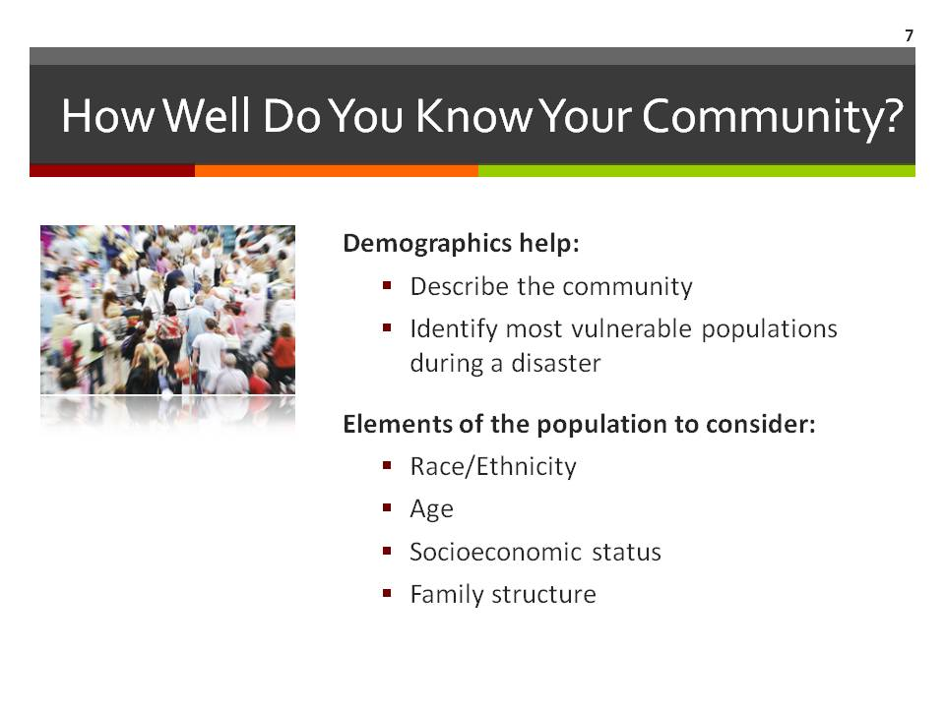  Supplies/Materials  Handout 2 – Data Sources*  Estimated Time  2 min.

STEP TWO Detailed Instruction

Slide 8  Population Trends: Windows to the Future  Considering population trends in disaster preparedness is another way to ensure all populations of the community are included.  Discuss the national trends on the slide.  Recent national trends show increasing:  - Minority populations (especially Hispanics)  - Elderly populations  - Number of economically disadvantaged  - Single-parent households  - One-person households  Ask participants:  - Are these trends happening in your area?  - Why might these national trends be important to your community as you form the planning team?  List the responses on the flip chart. | 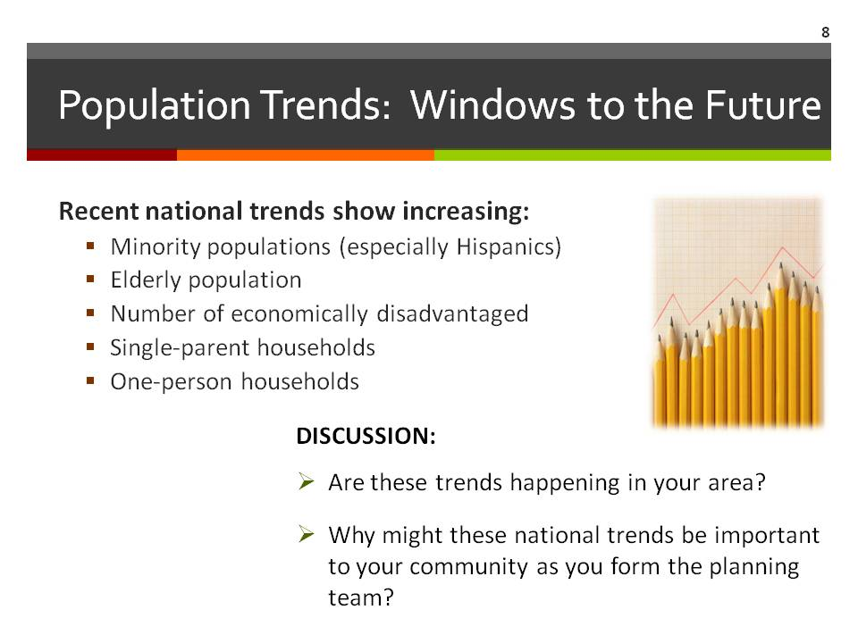  Supplies/Materials  Flip Chart  Markers  Estimated Time  15 min.

STEP TWO Detailed Instruction

Slide 9  Putting it on a Map  This is where participants will begin to map the community. Be sure to help them think about all of the things that should be included.  When completing the map of the community or county, be sure to include the following relevant places:  - Hazards – are there any geographic areas of greater concern?  - Flood Zones  - Earthquake Faultlines  - Landslide Zones  - Wildfire Zones  - Vulnerable populations – where do at-risk people live?  - Special Needs  - Elderly  - Low-Income  - Mobile Home Communities  - Important Places – where people gather or might seek help.  - Schools  - Day Cares  - Fire Stations (public and volunteer)  - Police Stations  - Hospitals  - Nursing Homes/ Senior Centers  - Churches  - Food Banks  - Institutions  - Shelters  - Humane Society  - Large Employment Centers  - At-risk Industries – where chemicals or other hazardous materials might cause a disaster or make an existing situation worse.  - Chemical Plants  - Factories | 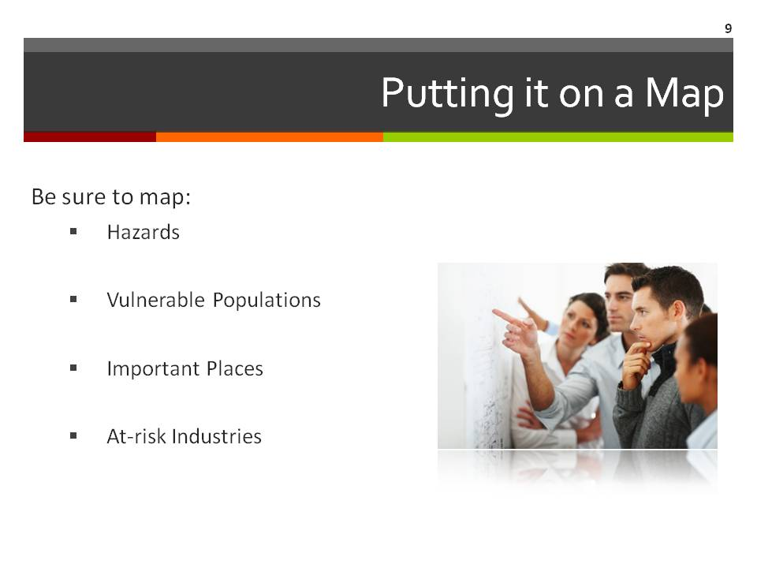  Supplies/Materials  Area Map (County/Town)  Markers  Stickers  Estimated Time  15-20 min.

STEP TWO Detailed Instruction

Slide 10  What Else?  Use this slide to get participants to take a moment to think about anything else they may need to know about in their community to plan effectively.  Use these questions to facilitate discussion:  - What do we know?  - What do we need to know?  - Who or what are we forgetting? | 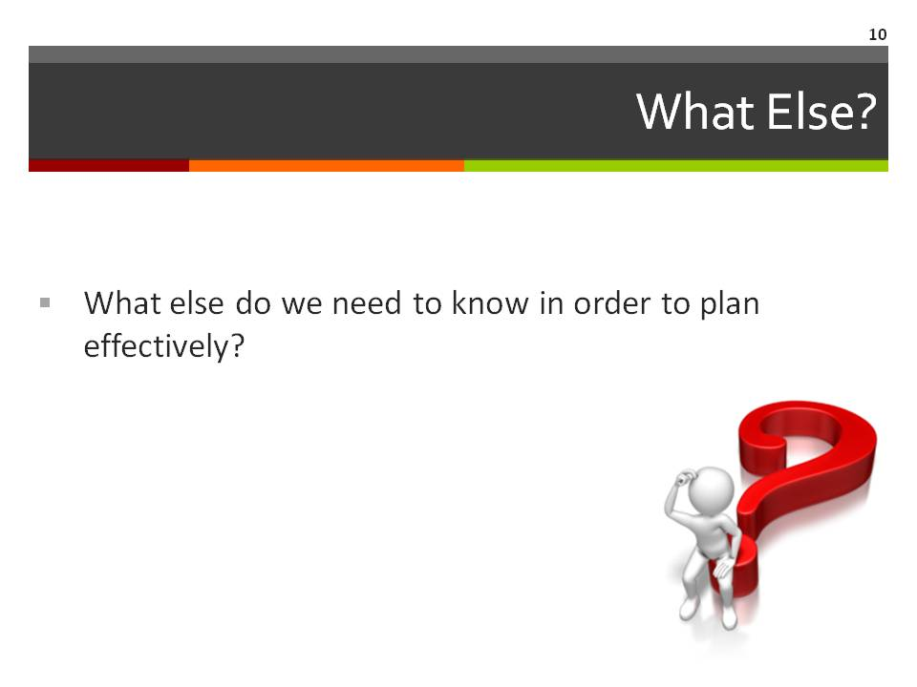  Supplies/Materials  Estimated Time  5 min.

Slide 11  When to Involve the Community  This slide is repeated from Step One as a reminder that the community’s involvement is needed in two places.  This section discusses the first of these:  - Verify and strengthen the information gathered. | 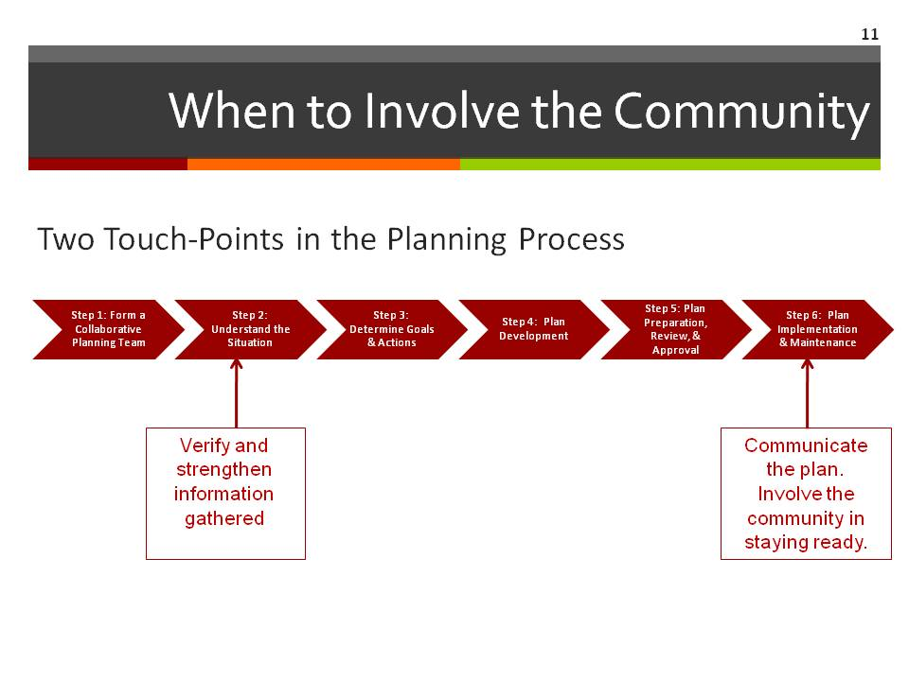  Supplies/Materials  Estimated Time  1 min.

STEP TWO Detailed Instruction

Slide 12  Preparing for the Community Ground-Truthing Open House  This slide gives a brief overview of preparing for the Open House. Greater detail is provided in Handout 3 – Ground-Truthing Open House Guide. The information on Handout 3 will be used to prepare the stations for the event, including the community maps that will be used.  - Complete all data gathering that is important to your community  - Prepare community maps  - Determine locations, dates, and times  - Send invitations and announcements  Be sure that locations, dates, and times are convenient for a wide range of community members. You may even want to consider hosting the event in multiple locations, dates, and times. | 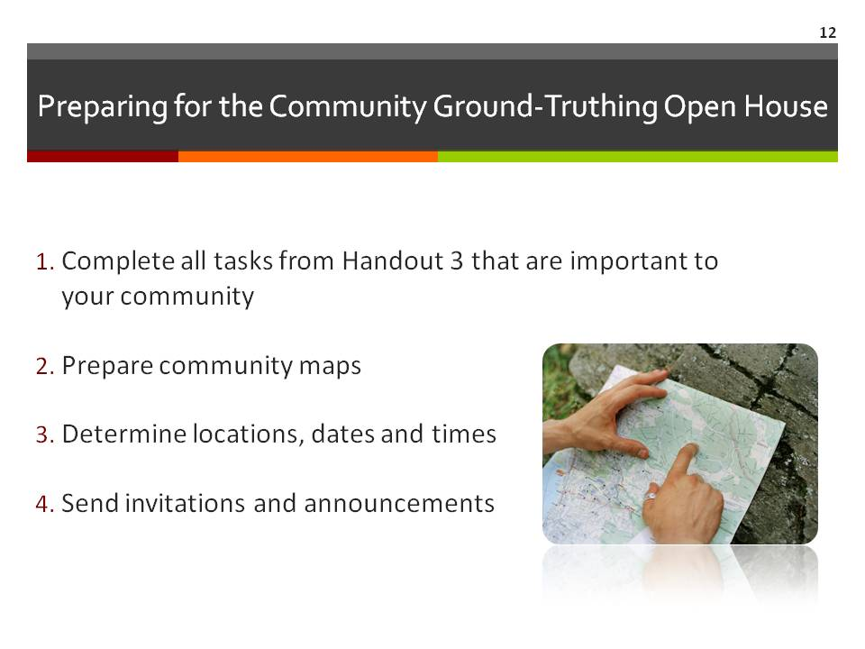  Supplies/Materials  Handout 3 – Ground-Truthing Open House Guide, Sample Open House Flyer, and Open House Fact Sheet  Estimated Time  10 min.

STEP TWO Detailed Instruction

Slide 13  Typical Open House Structure  Note to facilitator: This basic Open House structure is used for both touch-points in the ReadyCommunity Process when the greater community involvement is needed.  The information on this slide will help the group visualize the flow of the open house and assist them in making the logistical arrangements.  While the actual room setup can be adapted to the available meeting space, this diagram shows a typical structure, and includes:  - A welcome table placed at the entrance to greet and orient guests as they arrive.  - Stations placed around the room so that participants can easily move through them to review and add to the maps.  - A final comment area placed near the exit table so that participants can post final comments and learn about how to stay involved as they leave. | 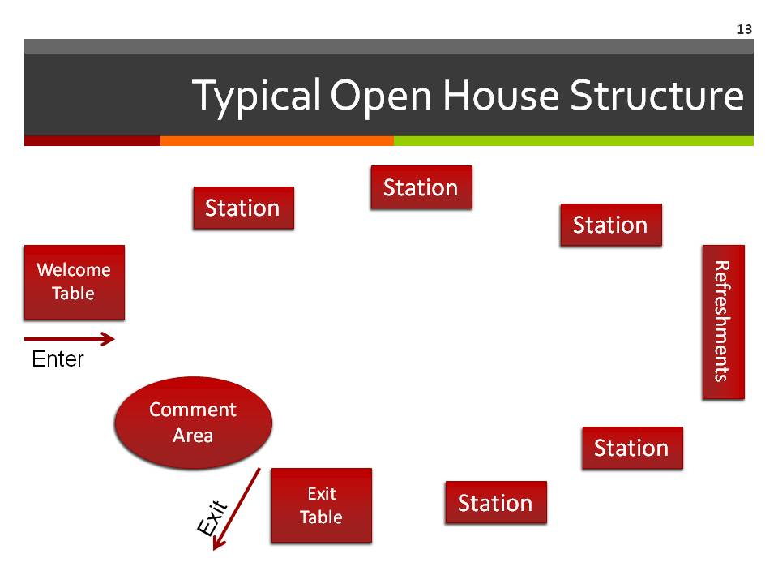  Supplies/Materials  Estimated Time  5 min.

STEP TWO Detailed Instruction

Slide 14  Where is Everyone?  Note to faciliator: Answers to these questions will give some insights into where to host the Open House event(s) and where to advertise. Some ideas are provided under each category to get the discussion started if needed.  This could be a good “get up and stretch” activity.  - Place the three bullet points from the slide on charts around the room and ask people to visit each chart and write down their ideas.  - This can be done informally or you can divide the group into three teams and have them visit each chart “round robin” style, asking each group to build on what the previous group has added.  As you consider hosting a ground-truthing open house, keep in mind the following:  Where do people in your community:  - Gather on a regular basis? (Church, school, work place, civic clubs, other?)  - Visit at least once a week? (Grocery store, beauty shop, gas stations, other?)  - Feel comfortable meeting? (Community centers, local restaurants, park, other?)  Bring the group back together and then ask them to go back to their list of vulnerable populations and consider how those individuals would answer the above three questions. Their involvement is crucial to the planning process since they are the ones most likely to suffer. The team needs to reach out to them and ensure their participation in the Open House. Add that information to the flip charts if not already included. | 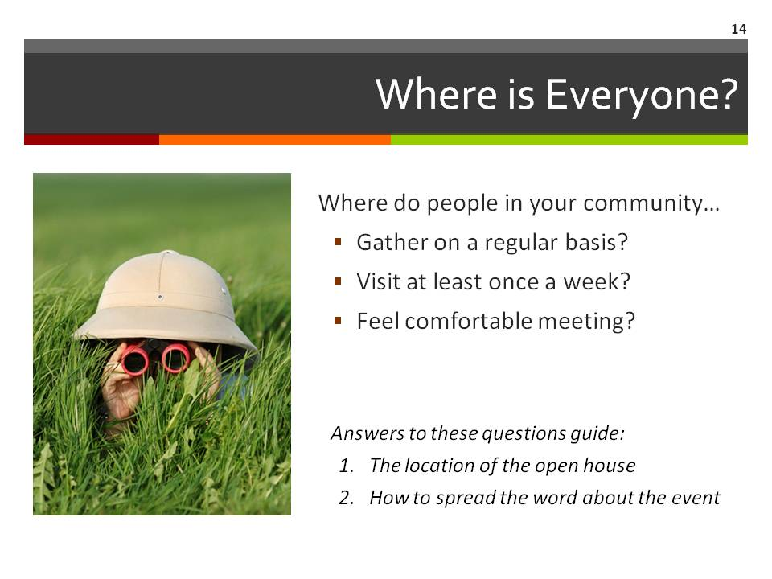  Supplies/Materials  Flip Charts  Markers  Estimated Time  10 min.
STEP TWO Detailed Instruction

Slide 15  After the Ground-Truthing Open House  The planning team needs to set aside time to examine the feedback received from the Open House participants.  Use the feedback to adjust maps and other assessment data to ensure that planning rests on the most accurate assessment.  Assign a person or team to provide follow up to participants that requested it. At a minimum, a thank you postcard or email would be a nice gesture. This could also include a reminder of the next Open House session if the dates are set. If the dates are not set, at least a “coming soon” note would be in order.  Also include a summary of how the community input helped the planning process. This could be a few short summary bullets such as:  - Helped identify additional homes vulnerable to flooding  - Added details to the challenges faced in the last flood (or whatever events were on the timeline)  - Helped us identify other neighborhoods that could be cut off in bad weather. | 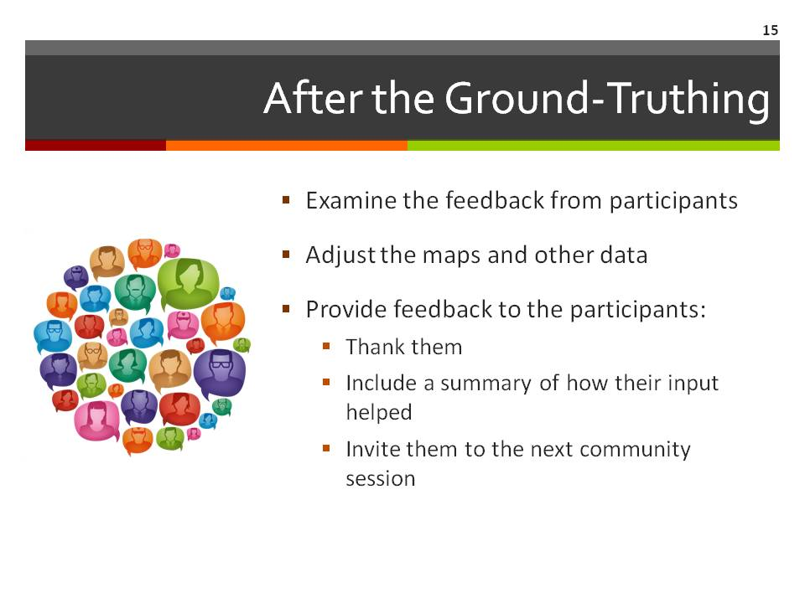  Supplies/Materials  Estimated Time  2 min.

STEP TWO Detailed Instruction

Slide 16  Questions and Discussion  - Next meeting date  - To do list  - Other discussions/questions | 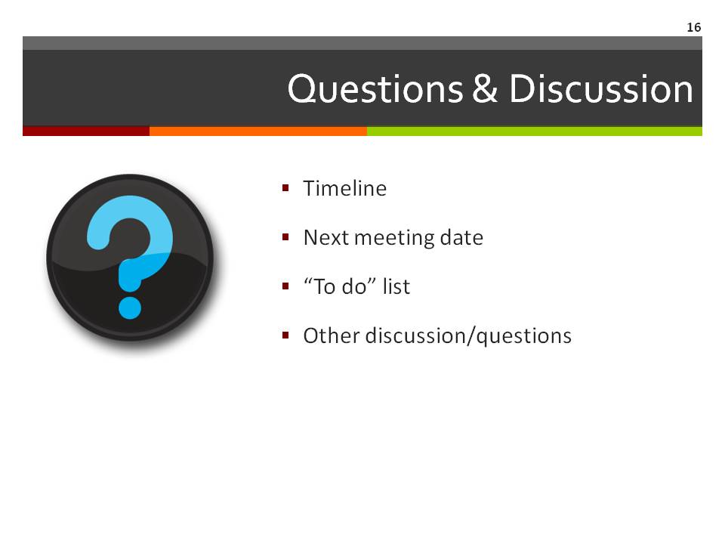  Supplies/Materials  Estimated Time  5 min.

Slide 17  Contact Information  Thank participants for coming.  Be sure to include your contact information as well as the local point person’s contact information so that all participants can stay connected to the planning process. | 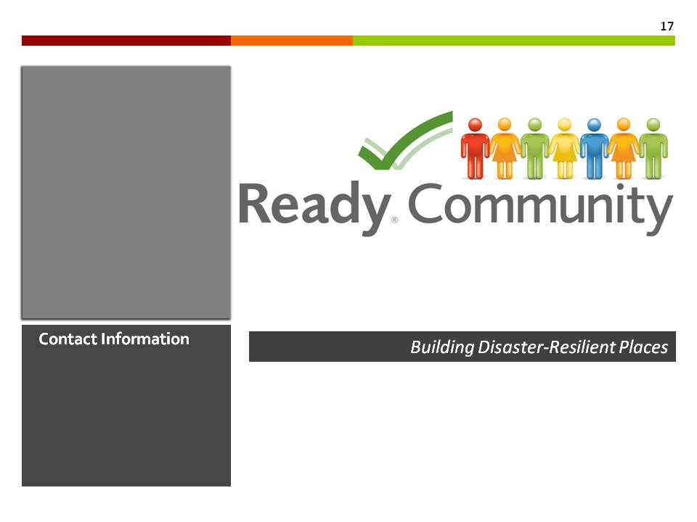  Supplies/Materials  Estimated Time  1 min.

