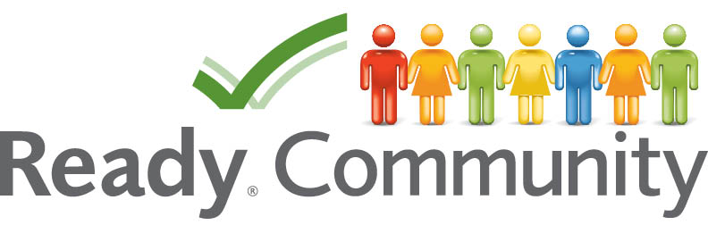
Job Descriptions
Core Team Responsibilities
- Work with the Coach in guiding the overall process
- Recruit others that can provide needed input and assistance
- Commit to participating in planning sessions
- Work as a team throughout all the planning experiences
- Prepare an Emergency Operation Plan aligned with state and federal guidelines

Planning Team Responsibilities
- Participate in planning sessions
- Contribute personal and professional knowledge to community assessments
- Help involve community members in larger events
- Assist in designing the Emergency Operation Plan
- Commit to keeping the plan current

Goals of the Combined Planning and Core Team
- Build and expand relationships
- Bring creativity and innovation to planning
- Define roles to be taken during a disaster
- Understand the roles and abilities of other organizations
- Establish a planning routine that aids in responding before, during, and after a disaster

Coach/Facilitator Responsibilities
- Supports the planning effort, from start to finish
- Helps organize the Core Team and Planning Team
- Facilitates the process that aids the Team in preparing a plan
- Helps coordinate community involvement
- Provides links to data and expertise available through partners

