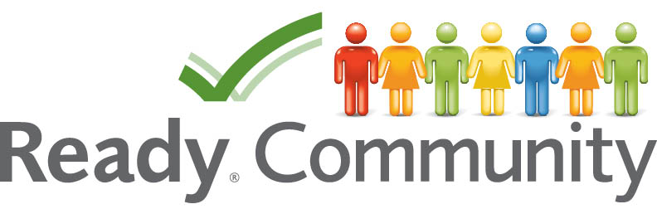

A companion guide to
FEMA’s Comprehensive
Preparedness Guide (CPG) 101

Introduction
In an effort to promote sound community-based emergency operation planning, the Federal Emergency Management Agency (FEMA) released an important booklet titled: “Developing and Maintaining Emergency Operations Plans: Comprehensive Preparedness Guide (CPG) 101” in November 2010. The Guide explains the steps for emergency planning and decision-making. In addition, it assists planners at all levels of government to develop and maintain reasonable all-hazards and all-threats emergency plans.

The major purpose of the ReadyCommunity resource materials is to work through the six steps outlined in the Comprehensive Preparedness Guide as vital to the development of a user-friendly Emergency Operations Plan (EOP). We note below the purpose of the CPG document and the “value-added” that ReadyCommunity offers to towns, cities, and counties.

Key Elements of the CPG 101 Process:
- Conduct community-based planning that engages the whole community
- Ensure plans are developed through an analysis of risk
- Identify operational assumptions and resource demands
- Prioritize plans and planning efforts to support their seamless transition from development to execution for any threat or hazard
- Integrate and synchronize efforts across all levels of government

How ReadyCommunity Helps Strengthen the CPG101 Guide:
- Provides a more detailed process to guide the work of local communities
- Outlines the important role of a neutral coach to facilitate the work of a local broad-based team
- Fosters broad civic participation to ensure buy-in from local residents and organizations
- Creates links to needed assets and resources both internal and external to the community
- Supplies current data to help guide the planning process
- Offers technical support on the analysis of data and potential alternatives

Overview of the ReadyCommunity Resources
The FEMA Guide outlines six important steps that are part of the “Comprehensive Preparedness Planning Process.” ReadyCommunity is aligned with these six steps, but offers more resources and guidance on how to effectively carry out each of the important steps. Here are the six CPG 101 steps as well as the “value-added” items that have been included in the ReadyCommunity guide.

STEP 1: Form a Collaborative Planning Team
- Understand the background and structure of the ReadyCommunity process
- Identify potential Core and Planning Team Members
- Design a recruitment message to foster participation
- Explore the value of engaging the whole community in the planning process

STEP 2: Understanding the Situation – Vulnerability and Resilience
- Define key elements of disaster management
- Determine how to assess threats, hazards, and risks
- Understand the elements of resilience
- Conduct a vulnerability assessment of people, property, and places
- Assess the types of threats/hazards the local area is at risk of experiencing

STEP 3: Determining Goals and Objectives
- Learn about the scenario planning technique
- Provide examples of the scenario planning process
- Understand the elements of SMART goals and actions
- Hazard/Threat Scenario Planning
- Develop SMART goals and actions for local hazards/threats

STEP 4: Developing the Plan
- Explore possible options for achieving the SMART goals and objectives
- Assess the community’s capacity to carry out the possible options
- Select the most viable options
- Develop a detailed implementation plan

STEP 5: Plan Preparation, Review, and Approval
- Launch process for completing the written preparedness plan
- Evaluate the plan’s performance in a scenario situation
- Take steps to get the plan approved and disseminated

STEP 6: Implementing, Reviewing, Revising, and Maintaining the Plan
- Establish a strategy for testing the plan
- Develop timeline to review and keep plan relevant and up-to-date

The Responsibilities of ReadyCommunity Participating Communities
- Establish core and planning teams comprised of individuals who are committed to attending all training sessions
- Recruit teams members that are willing to do the hard work needed throughout the ReadyCommunity planning experiences
- Develop working plan and actively engaging the broader community to strengthen and fine-tune a local emergency operation plan.
- Finalize an Emergency Operations Plan (EOP) that is consistent with state and federal guidelines
- Commit to keeping the Emergency Operations Plan (EOP) sustainable

