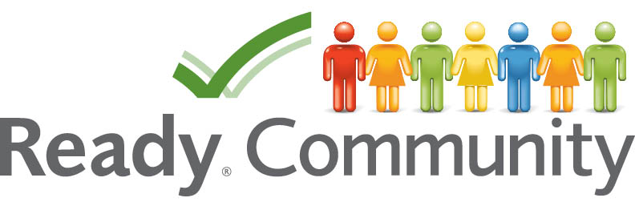
STEP SIX
Plan Implementation and Maintenance

By Virginia Morgan
Alabama Cooperative Extension System
Auburn University

This facilitator’s guide outlines the content, activities, and handouts that should be used to teach this section. Refer to this document for detailed guidance on how to deliver ReadyCommunity Step Six.
STEP SIX
Plan Implementation and Maintenance

Before Starting Step Six…
Prior to moving on to Step Six, the core and planning teams should complete these activities from Step Five:
- Scenario Assessment of the Emergency Plan (Step Five – Handout 4)
- Approval and Distribution of the Plan
- Develop Community Education Materials (Step Five – Handouts 5 and 6)

Overview
A plan that has incorporated the comments and accounted for the needs of all sectors of a community takes a while to build, but it isn’t complete until you establish a schedule for implementing and maintaining the plan. This module helps close the loop in the planning process and establish the base for the next planning cycle.

Objectives
This Module will help facilitate:
- Establishing a strategy for testing the plan
- Creating a schedule for maintaining the plan

Estimated Time to Complete Step Six Activities
Two and a half hours

References to FEMA’s CPG 101
Pages 4-2 to 4-6

References
Emergency Planning Exercises for Your Organization http://www.fema.gov/privatesector/exercises.shtm

FEMA Lessons Learned Information Sharing: Community Preparedness https://www.llis.dhs.gov/DynamicPage.do?pageTitle=CommunityPreparednessEX

Emergency exercise and training techniques http://www.ema.gov.au/www/emaweb/rwpattach.nsf/VAP/(3A6790B96C927794AF1031D9395C5C20)~Emergency_exercise_and_training_techniques.pdf/$file/Emergency_exercise_and_training_techniques.pdf

Homeland Security Exercise and Evaluation Program https://hseep.dhs.gov/pages/1001_HSEEP7.aspx

Homeland Security Exercise and Evaluation Program, Volume I HSEEP Overview and Exercise Program Management, pp. 9-12 https://hseep.dhs.gov/support/VolumeI.pdf

Plan Implementation and Maintenance
This session should include all planning team members if possible. During this session, the coach will lead the planning team through the final step of the planning process. Participants will discuss the importance of training and exercising the plan. They will also develop a schedule for reviewing the plan. All plans need to finally move to implementation. One person usually assumes responsibility for leading this stage of the process. For an emergency plan, the local emergency manager is the most probable person for this role, but that may vary by community.

Advance Preparation

One Week Prior
- Follow up with local point person
  - Confirm final count
  - Discuss any questions/concerns that may have surfaced
  - Discuss homework
- Send reminder to attendees
  - Confirm date, time, location
  - Go over what they should expect, their responsibilities
- Confirm food and beverages, if being provided, with local point person
- Double check logistical arrangements
- Print handouts (See “Supplies Needed” below)
- Add your contact information to Slide 19 in PowerPoint “ReadyCommunity – Step Six”

Day of Event
Arrive at meeting place at least 45 minutes prior to meeting in order to:
- Set up PowerPoint equipment. Have the first slide displayed as participants arrive.
- Arrange tables and chairs so that participants can be face-to-face. A U-shape works well with the projector screen in the opening of the U.
- Prepare a sign-in table so that you can ensure you have accurate contact information for all participants.
- Set up refreshments (optional).

Supplies Needed
Talking Points from Step Five
Copies of the full Emergency Operations Plan
Handout 1 – Implementation in Normal Times: What and When
Handout 2 – Review, Revise and Maintain the Plan
Handout 3 – Activities to Sustain Community Commitment
Handout 4 – Tips for Hosting a Successful Community Fair
Handout 5 – Who to Invite?
“Ready” and “Not Ready” signs (From Step One)
Handout 1 – Are We Ready (from Step One)
Calendar
Computer
Projector
Screen or blank wall
Extension cord
Flipchart & easel
Markers
Sign in sheet
Nametags and name tents (unless all participants are well acquainted)
Calendar
Map of county/community

Support Documents
Comprehensive Planning Guide (CPG 101)

STEP SIX Detailed Instruction

Slide 1  ReadyCommunity  Welcome slide – have up when participants enter the room.  Warm up:  Ask each person to share the following information:  - Name (If they are not already acquainted)  - One good thing they have seen from the process thus far. | 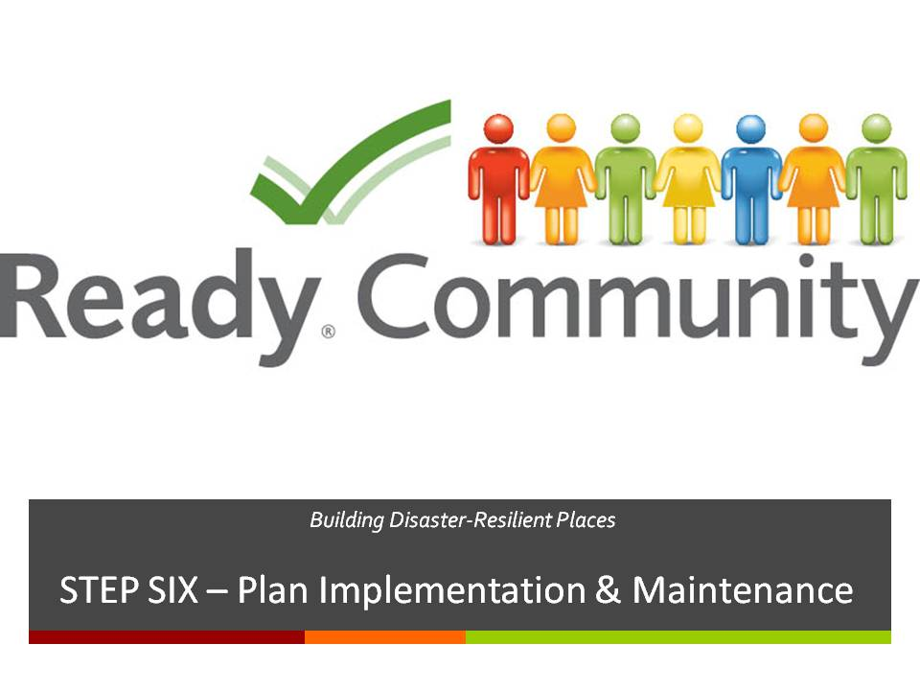  Supplies/Materials  Estimated Time  10-20 min. (depending on size of the group)
Slide 2  A Review of What is Involved  As discussed earlier, the ReadyCommunity process follows six basic steps as outlined in CPG 101 and shown here.  Today the focus is on Step Six: Implement and Maintain the Plan.  The purpose of this step is to close the loop in the planning process and establish a timeline for the next planning cycle.  This will involve:  - Testing the plan regularly  - Creating a schedule for maintaining the plan  - Finalizing how to keep the plan “alive” | 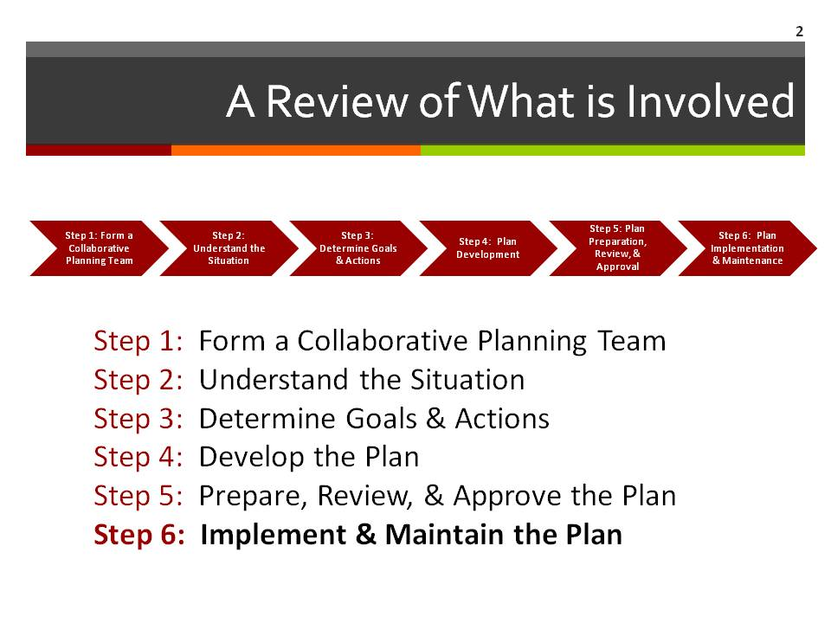  Supplies/Materials  Estimated Time  1 min.
STEP SIX Detailed Instruction
Slide 3  Reviewing the Plan  When should you review and revise?  - Some teams agree to review sections of the plan each month or each quarter, and the full plan once a year.  - All plans should be reviewed at least once every two years.  Ask participants:  Please take a few minutes now to decide on how often the plan will be routinely reviewed for revision and who will be responsible.  List responses on the flip chart.  The most effective plans are those that are exercised, reviewed, and revised on a regular basis. | 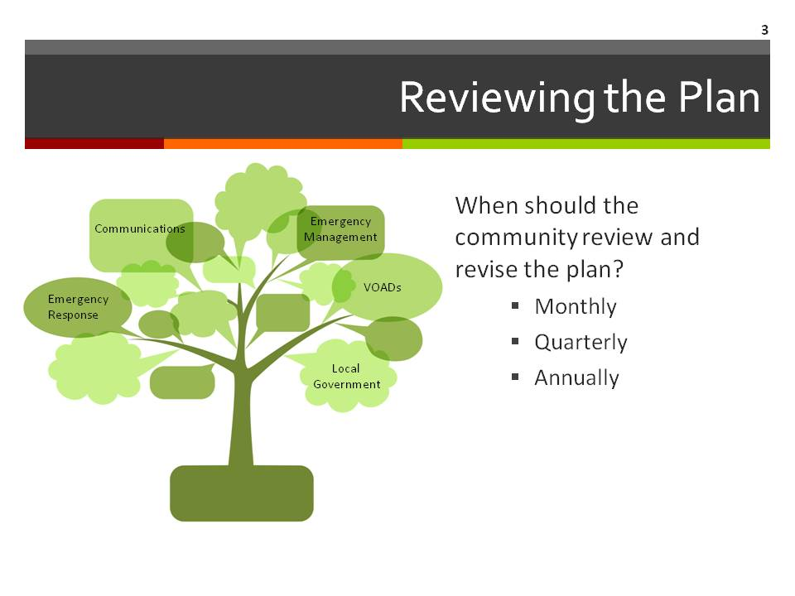  Supplies/Materials  Flip Chart  Markers  Handout 1 – Implementation in Normal Times: What and When?  Estimated Time  15 min.

Slide 4  Reviewing: Special Situations  In addition to the regularly scheduled reviews, consider planning to review and revise after:  - Major incidents and exercises  - Changes in elected officials, demographics, laws or ordinances  Schedule routine maintenance to ensure:  - Role assignments are current  - Information is accurate  - Procedures are effective  - Aligns with laws and jurisdictions  When else might you need to plan?  What else could you change? | 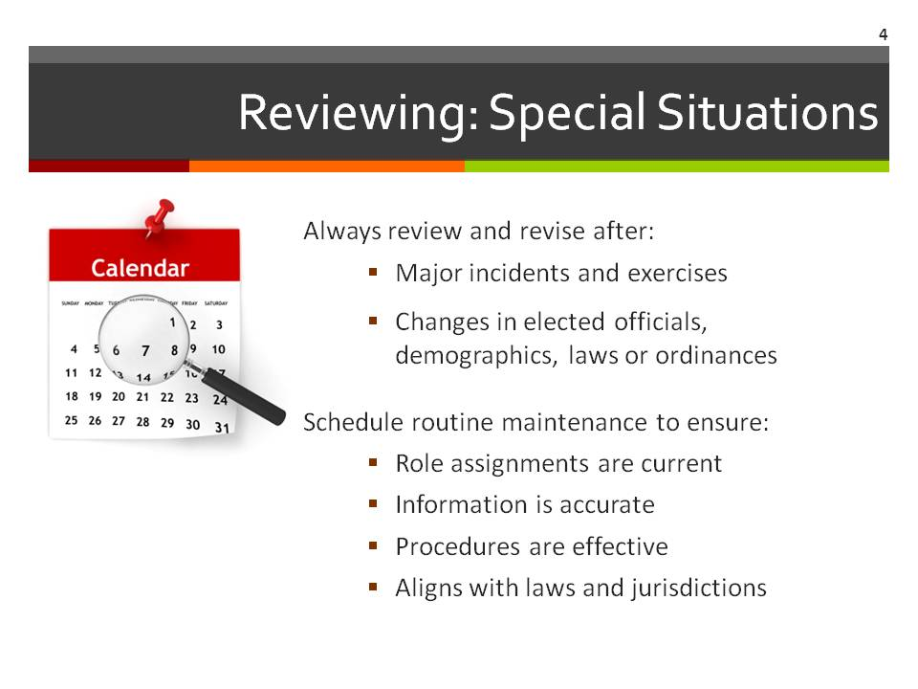  Supplies/Materials  Flip Chart  Markers  Handout 2 – Review, Revise, Maintain Worksheet  Estimated Time  5 min.
STEP SIX Detailed Instruction
Slide 5  Action: Exercise the Plan  What’s the difference between training and exercising? Training focuses on individuals while exercises focus on the plan.  Provide training when:  - New people are hired or volunteer  - Job duties/tasks are reassigned  - The plan changes  Exercise the plan to:  - Develop/refresh skills  - Orient partners to their roles  - Assess the plan  - Strengthen connections among the various partners  While training is not part of the community team’s responsibility, this team can help stress the importance of training to the groups that members represent. The ability of an organization or business to respond to an emergency contributes to the overall community resilience.  Distribute copies of the Emergency Operations Plan. Review the section for responsibilities, deadlines, and documentation notes. With this in mind, let’s look at options for exercising the emergency operations plan. | 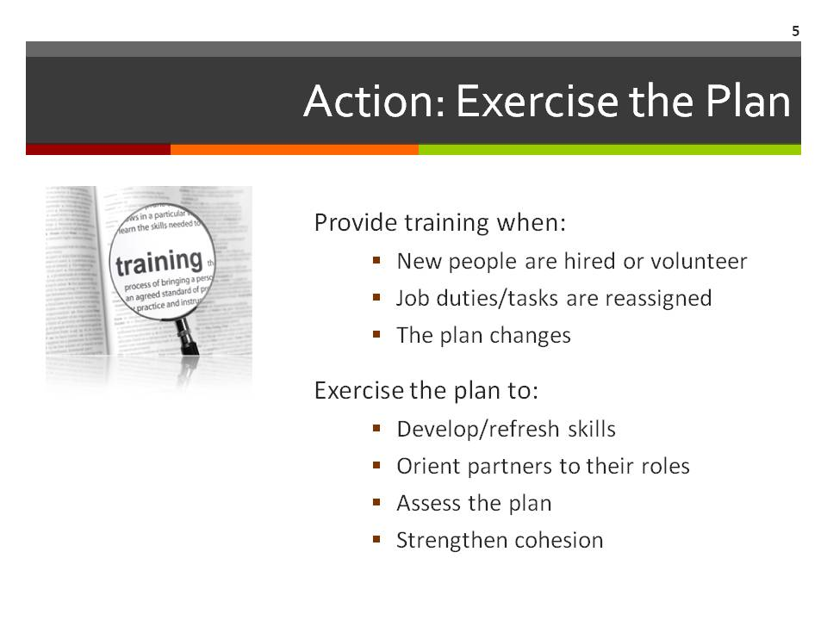  Supplies/Materials  Flip Chart  Markers  Copies of the Emergency Operation Plan  Estimated Time  30 min.

STEP SIX Detailed Instruction
Slide 6  Exercises  Distribute Handout 5 – Exercise Your Plan.  Review the handout with the group.  The four discussion-based exercises are facilitated discussions in informal environments. Review the discussion-based exercises:  - Seminars or lectures are primarily one-way communications in which you provide an orientation or overview of your topic.  - Workshops focus on specific goals—this session is in a workshop setting.  - A tabletop exercise is the next step in complexity. Only key personnel are involved in tabletops. A scenario about an event such as a flood is provided to the group. Then they talk about how they would respond to the event, based on the emergency operations plan.  - Games are more complex, but still conducted without actually using equipment or resources. Games simulate operations and may involve two or more teams.  Operations-based exercises are action-oriented and usually include a larger number of people. Discuss the operations-based exercises:  - Drills take the concept of games one step further in complexity. Drills may include activities such as evacuating a building to a designated location, or using new equipment: did the evacuation and report-in work as anticipated? Did the equipment work properly?  - Functional exercises are intended to add stress and time constraints to the activity.  - A full-scale exercise is the most complex of exercises and requires multi-agency, multi-jurisdiction, and multi-organization coordination.  Ask participants:  - Do you have any experiences using the exercises?  - Which exercise types can your community most realistically use?  List responses on the flip chart. | 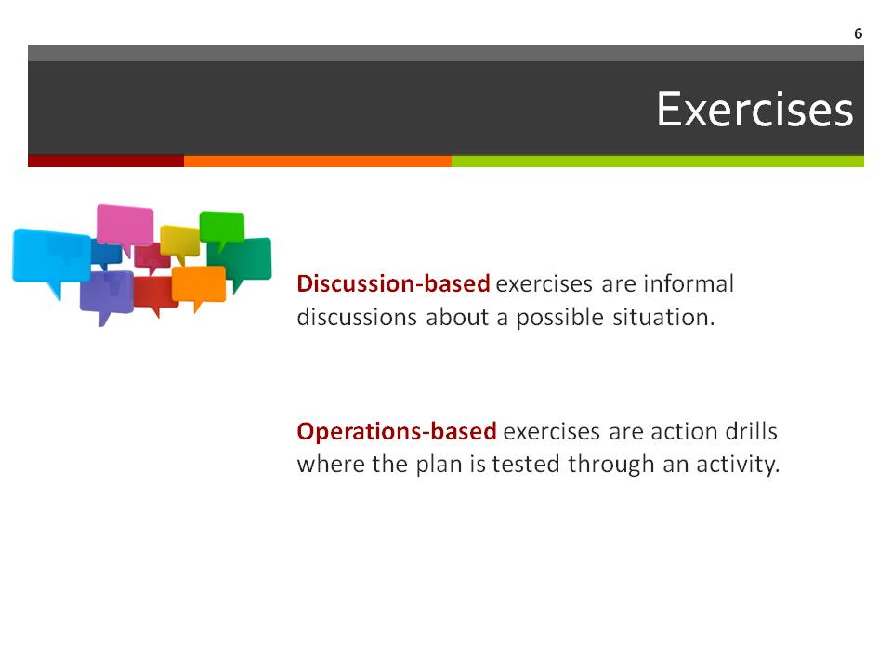  Supplies/Materials  Flip Chart  Markers  Estimated Time  5 min.

STEP SIX Detailed Instruction
Slide 7  Action: Evaluate Exercises  Evaluation is important after an exercise. An evaluation may identify problems to be addressed when you revise the Emergency Operations Plan.  Each time you offer training or conduct an exercise, record the lessons learned from each. Here are three ways to capture that information. | 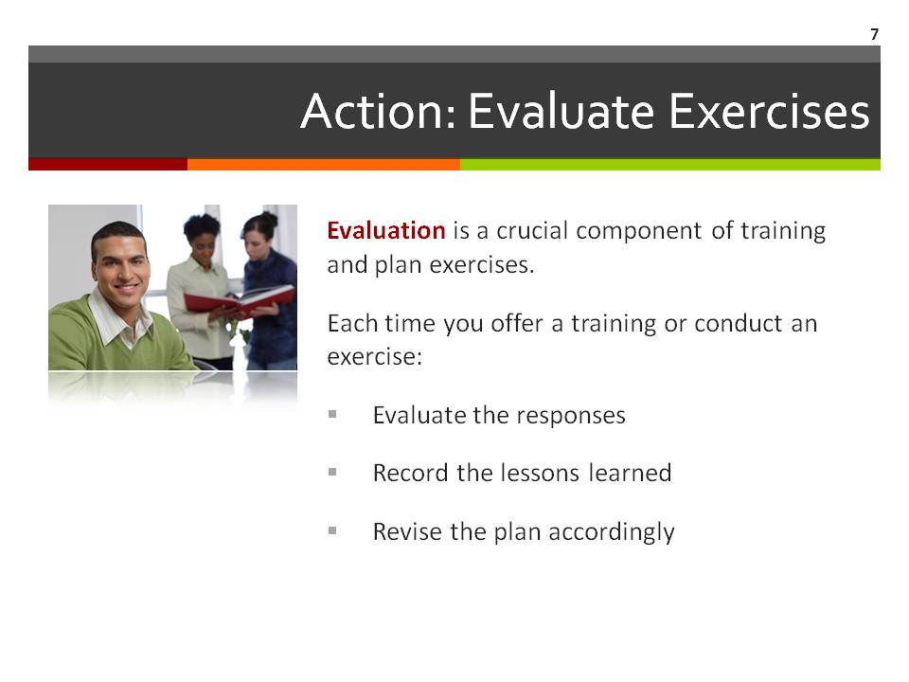  Supplies/Materials  Estimated Time  5 min.

Slide 8  Sustainability  In Step Five, the team developed a public education plan that included ways to inform the community about key components of the emergency plan.  Discuss specific ways to keep the community commitment.  How can we be sure the community gets involved and stays involved? (Discuss in groups or use Handout 3 to record answers)  Organize a team to help the Emergency Manager with community involvement. | 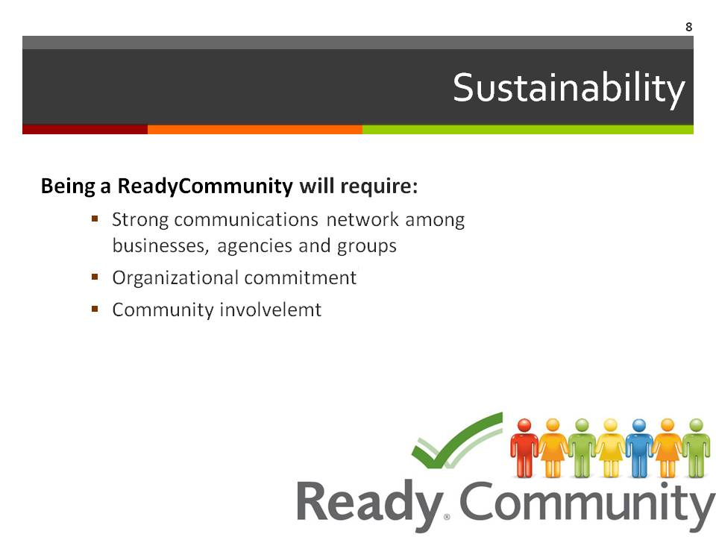  Supplies/Materials  Flip chart  Markers  Handout 3 – Activities to Sustain Community Commitment  Estimated Time  10 min.

STEP SIX Detailed Instruction
Slide 9  Building Community Skills: The “Final” Touch-Point  The final touch point in the planning process is to involve the community in learning how to be prepared and where they fit within the existing plan effectively.  Similar to the previous community events, this event will take the shape of a community fair.  Notice that “final” is in quotation marks. That is because, as we have discussed throughout this session, there is really no “final” step in emergency planning in that you never put it on the shelf and call it “done.”  Communities need to be always working at keeping the plan alive. | 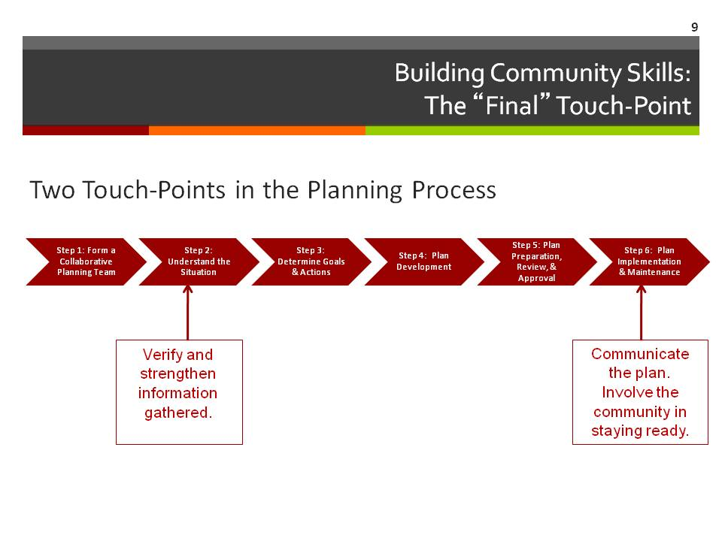  Supplies/Materials  Handout 4 – Tips for Hosting a Successful Community Fair  Estimated Time  5 min.
Consider tagging this event along with another community event to increase participation and access.

STEP SIX Detailed Instruction
Slide 10  Goals of the Community Fair  The goals of this community fair are three-fold.  - The first is to provide the education and resources the individuals need in order to prepare their own families for disasters.  - The second is to foster community volunteerism that can be tapped in the face of a disaster.  - Finally, helping community members link to organizations that provide disaster-related training will strengthen both the individual and community responses.  Who in your community offers these types of educational resources?  Use Handout 5 – Who to Invite? to begin identifying agencies that may be willing to participate.  Alow time for initial planning now. If additional planning time is needed, be sure to set a next date/time to plan. | 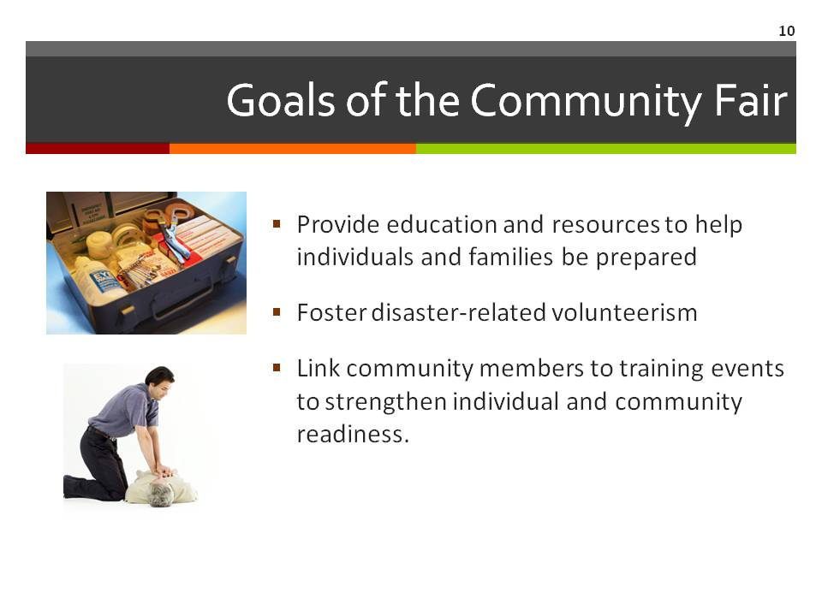  Supplies/Materials  Flip Chart  Markers  Handout 5 – Who to Invite?  Estimated Time  20 min.
STEP SIX Detailed Instruction

Slide 11  Are We Ready - Revisited  Repeat this exercise used in Step One.  Ask participants to take a moment to complete the short worksheet “Are We Ready to Plan?”  Have them total their response numbers. Explain that they are to answer each question to the best of their own personal knowledge, Treat “I don’t know” as “no.”  Place the two signs “Ready” and “Not Ready” on opposite sides of the room (or some reasonable distance apart to allow participants to take a position between them based on their total scores). Have participants view the space between the two signs as a continuum with “Ready” being a maximum score of 70 and “Not Ready” being a score of 14.  Ask them to all come take a place along the continuum that best represents their total score.  Lead a discussion based on their positions. These questions may serve as guides:  - What do you observe about the group’s scores?  - How is this different from our original assessment?  - What do you think has changed?  - What is better?  - Where do we still need to do some work?  - How do you think others in this community that have not been through this process with us would score the community?  Use answers to these questions to guide any additional steps that are needed. |  Supplies/Materials  Handout 1 (Step One) – Are We Ready?  “Ready” and “Not Ready” signs  Estimated Time  20 min.

STEP SIX Detailed Instruction
Slide 12  Questions and Discussion  Review any items that the group needs to consider in preparation for keeping the plan “live.”  What planning needs to take place for the community fair?  Is additional work needed to finalize the plan? If so, consider scheduling a work day dedicated to finishing.  The slide provides some structure to this discussion, but feel free to add other items that are relevant to the group.  List responses on the flipchart. | 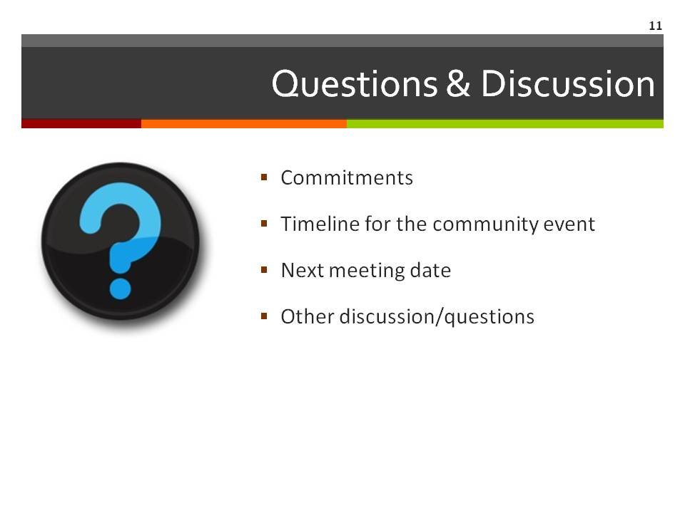  Supplies/Materials  Flip Chart  Markers  Estimated Time  5 min.

Slide 13  Contact Information  Thank the team for their great work today.  Be sure to include your contact information as well as the local point person’s contact information so that all participants can stay connected to the planning process. | 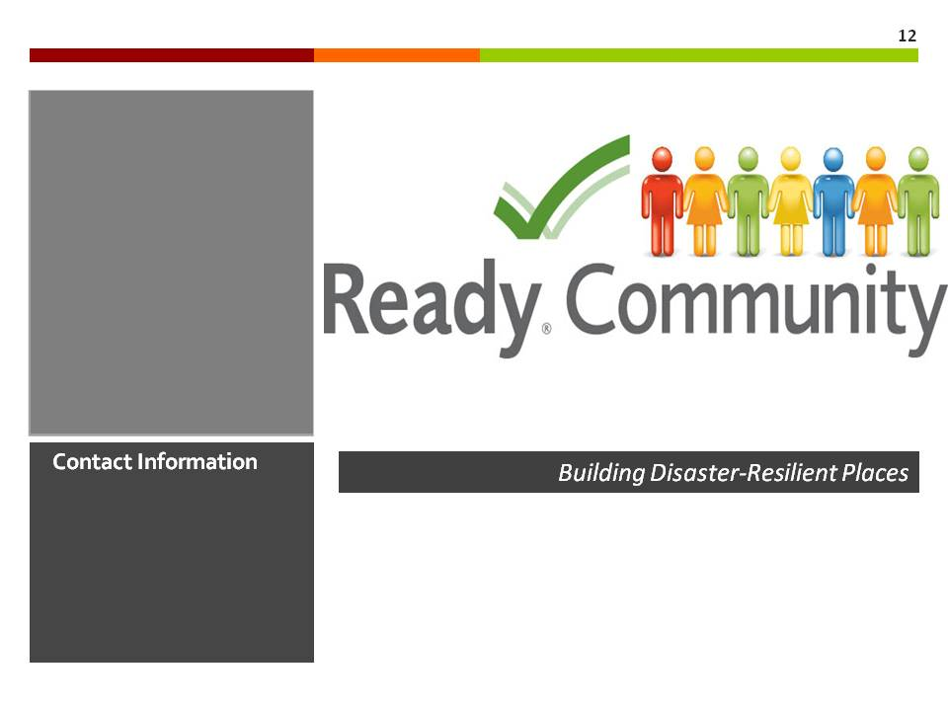  Supplies/Materials  Estimated Time  5 min.

