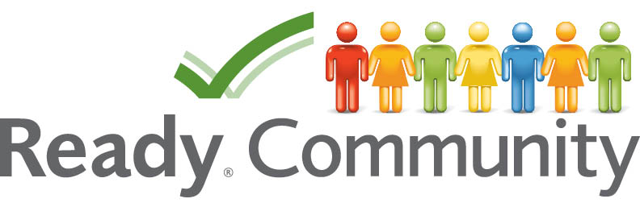
ReadyCommunity
Pre-Planning Agenda

- Introductions (if needed)

- Overview of the planning steps (ReadyCommunity handout)

- Geographical boundaries of the planning process
  - What geographical boundaries make sense for the project? Why?
  - Do these boundaries cross-jurisdictional lines?

- Designing a tentative timeline
  - When would you like to see the process complete?
  - Are there any internal or external elements driving the date (grant opportunity, legal requirement, etc.)

- Identifying existing plans
  - When were they completed?
  - What were the geographical boundaries?
  - What kind of plan was it? What hazards were included?

- Determining potential core team members – In a disaster, who are people that:
  - Are expected to respond (emergency agencies)
  - Have responsibility for large numbers of people at any point (schools, large companies, etc.)
  - Have access to and/or control key community resources (utilities, city manager, etc.)
  - Have the power to make community-wide decisions
  - Can reach a large group of people quickly (faith-based, community orgs, etc.)
  - Have access to those that might be most at risk of harm or danger

- Discussion of any initial concerns/barriers

- Logistics of first meeting

