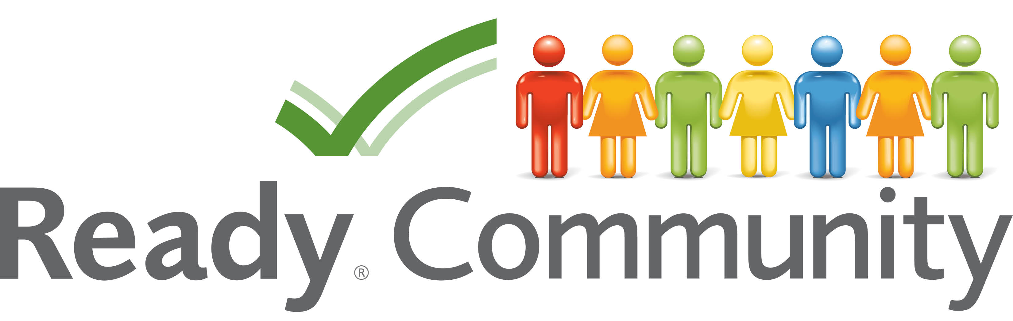

Is your community a ReadyCommunity?
Attend the Open Houses and help us find out!

A ReadyCommunity is one that:
- Knows the threats that the community is likely to face
- Thinks about who might need extra help in a disaster
- Links community people and organizations to help prepare and respond to a disaster
- Listens to the advice of community members in making plans for disasters
- Helps people in the community know how to be prepared for a disaster

What ReadyCommunity Does:
- Provides a process to help local communities build a community disaster plan
- Brings together the voices of community members to help guide the plan
- Helps uncover resources both inside and outside the community that can help the community prepare

What you can do to help:
Attend the open houses and share with us your community insights!
The planning team in [COMMUNITY/COUNTY] is hosting four open houses to get help from community members.
The purpose of each open house is:
- Open House One – community members will help:
  - Identify where people live that might it difficult to respond to a disaster
  - Revise a map of places that may be in danger in a disaster
- Open House Two – community members will help find community skills and resources that would aid in a disaster
- Open House Three – community members will help review the main points of the disaster plan to help the planning team identify any other changes that are needed.
- Open House Four – community members will join a celebration and community fair to learn how they can help support the community’s plan to be a ReadyCommunity.

Join us for the next open house!
Open House [#]
When:
Where:
For further information, contact:

