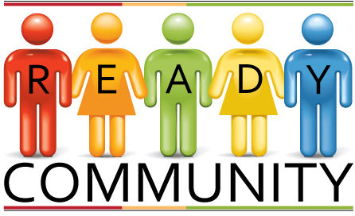
Job Descriptions
Core Team Responsibilities
- Recruit others that can provide needed input and assistance
- Support the Coordinator/Facilitator in guiding the overall process
- Commit to attending planning sessions
- Work as a team throughout all the planning experiences
- Prepare an Emergency Operation Plan aligned with the FEMA guidelines
- Manage meeting logistics (e.g., location, food, etc.)

Planning Team Responsibilities
- Participate in planning sessions leading to development of an Emergency Operations Plan
- Contribute personal and professional knowledge to community assessments
- Help involve community members in larger events
- Assist in designing a comprehensive community approach to disasters
- Commit to keeping the plan alive and fresh

Goals of the Combined Team
- Build and expand relationships
- Bring creativity and innovation to planning
- Define roles to be taken during a disaster
- Understand the roles and abilities of other organizations
- Establish a planning routine that aids in responding before, during, and after a disaster

Coach/Facilitator Responsibilities
- Recruit others that can provide needed input and assistance
- Guide and keep track of the overall process
- Insure team members stay connected and informed
- Prepare meeting materials (e.g., handouts, flip chart pads, markers).

