Open House Fact Sheet

What is an Open House?
An open house is an informal meeting process where participants begin by examining various displays, or stations, related to the meeting purpose. Each station is staffed with a knowledgeable person assigned to answer questions that may arise as participants explore. Generally, some type of input process is incorporated into the meeting so that participants can voice concerns, add missing information, or make other relevant suggestions or comments.

When is it Useful?
This basic open house design can be expanded and adapted to meet many purposes. This structure can be particularly effective in:
- Helping the community understand a complex community project or problem
- Providing a non-threatening atmosphere for the public to provide input
- Attracting a broader audience than more formal public meetings

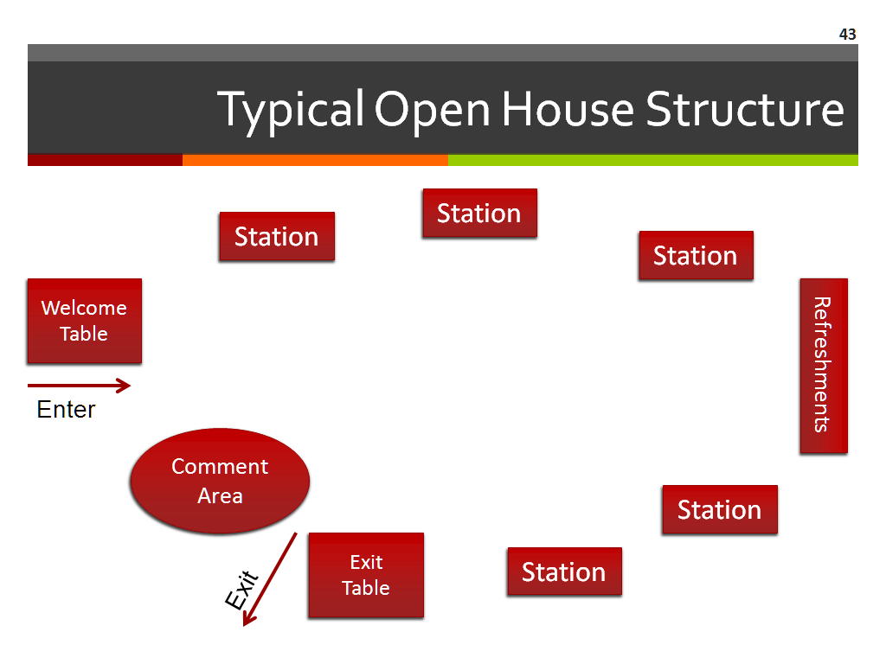
How is the Open House Structured?
The basic outline typically follows this pattern:
- Participants arrive at a welcome table where they:
- Sign in and get a nametag
- Are given an overview of the various stations they will be exploring, typically including a room diagram with brief descriptions of each station to help guide their discovery
- Learn about the input process that will be used at the session so they can offer their
input effectively.

- Participants walk through the various stations at their own pace, staying as long as they like at each one.

- Participants visit a final station as they exit that is set up with staff assistance to:
- Ensure that each person has been able to record his/her comments, suggestions, and concerns.
- Provide information about how participants can receive follow up information.

How long does an Open House last?
The length of time is dependent on several factors such as the number of stations you want to include, the number of participants you expect, and how you want to involve participants in getting their input. Another factor to consider is what time frame would best work for your target audience. You may choose to host a longer event to accommodate people with broadly diverse schedules. Or you may wish to hold the same event at multiple dates, times, and locations to increase input. While all of these considerations impact the amount of time to set, a good rule of thumb is to allow at least two hours.

