Using Census.gov to Retrieve Community Data

The Census website is an excellent resource for data on your community, county, and state, and the nation. Here’s how to navigate the Census.gov website.

- Go to the Census website at http://www.census.gov
- Click on the ‘Data’ tab located at the top of the page and then click on ‘Quick Facts’ as pictured below.

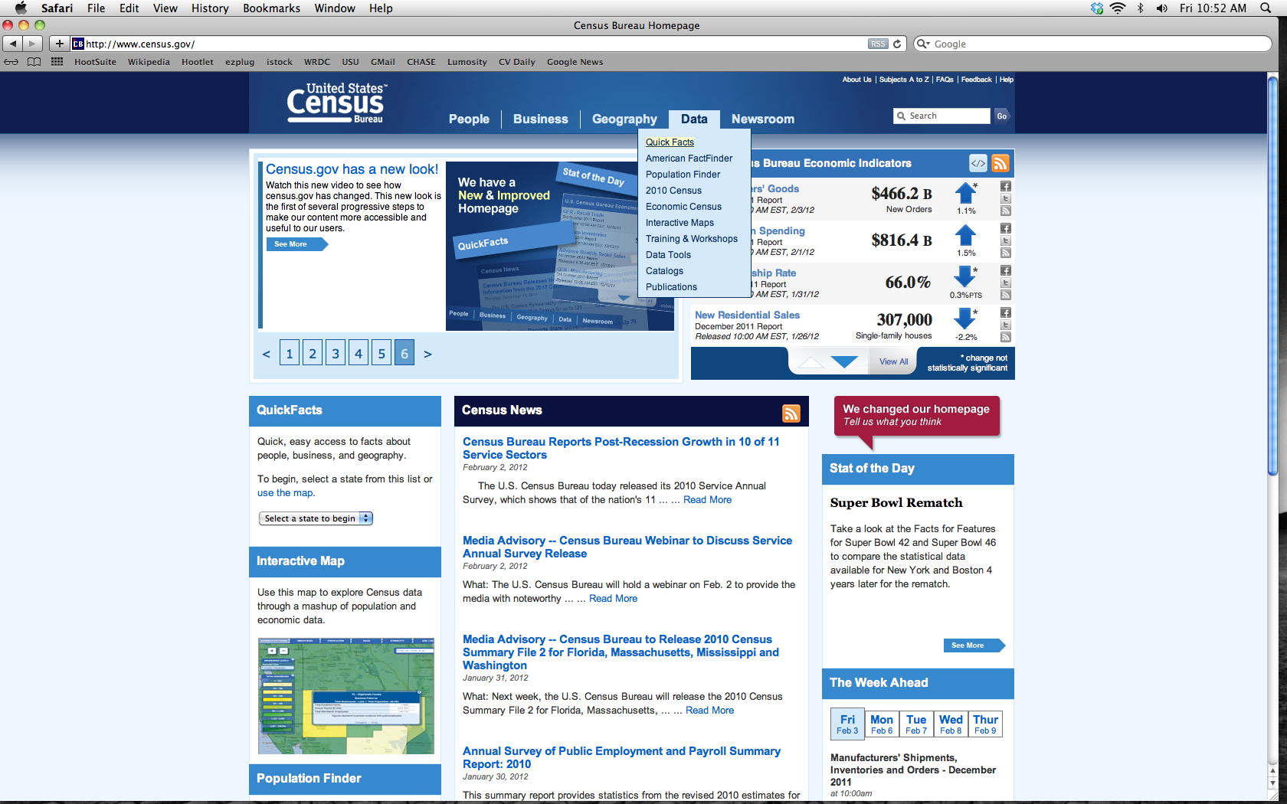

- Next, choose your state from the drop down menu and then click the ‘Go’ button, or use the map of the U.S. and click on your state.

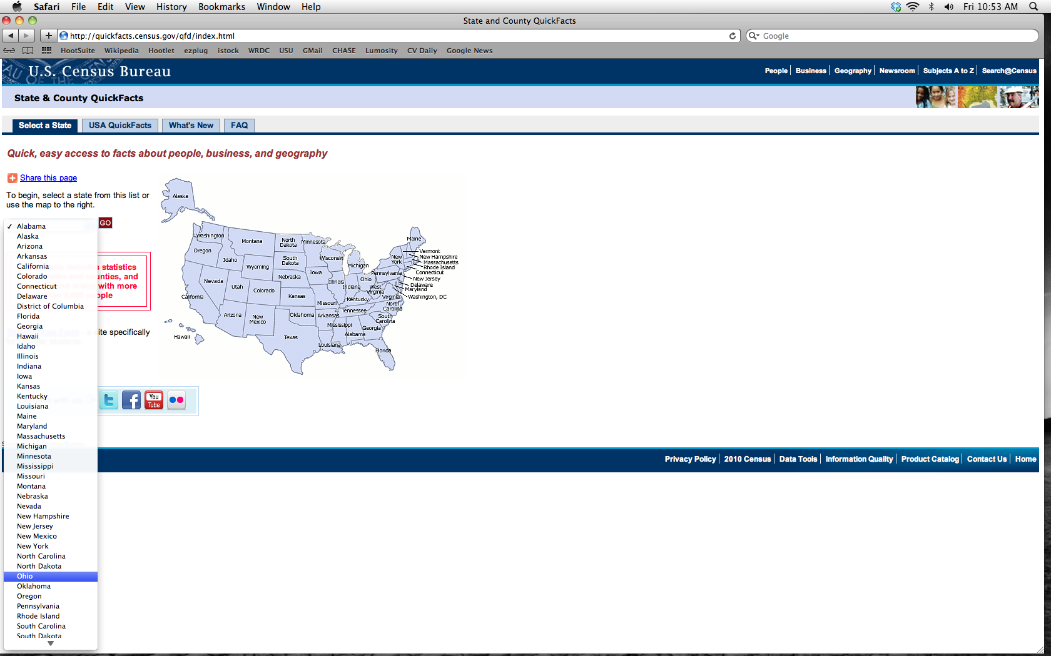
- Now you are on a page with information specifically related to your state. From the drop down menu select a county or a city. Then click on the ‘Go’ button. You will now be on a page with data pertaining to your county/city selection.

